JCMME 2018 Registration Form
2018 International Joint Conference on Metallurgical and Materials Engineering
Dec. 10-12, 2018 | Wellington, New Zealand | www.jcmme.org
NOTE: Please send the required documents: 1. final paper(doc&pdf), 2. filled registration form, 3. Payment Voucher to jcmme@iased.org to finish the registration. (Mail Subject: Paper ID+Registration).
- ATTENDEE INFORMATION
*Full Name:

1-inch-Photo here
*Position√: Prof. □  Assoc. Prof. □  Asst. Prof. □ Dr. □  Mr. □  Ms. □
*Affiliation & Country:
*Email: *Mobile:
Emergency Contact(Name&Mobile):
Address& Zip Code (for post use):
Catering Service(Dec.11)√: Lunch □ Dinner □
Special dietary√: Diabetic □ Vegetarian □ Muslim □ Other □ (please specify: )
Special requirements:
- PAPER INFORMATION
*Paper ID: *Paper Pages: *Additional Page:
*Paper Tile:
*Authors:
*If you’ll be present the conference Yes □ No □
*Presentation Terms√: Oral □ Poster □ Remote Video □ Video □
Student ID No.(student only):
IASED Member No.(member only):
* Receipt Issued to:
- REGISTRATION FEE(by US dollar)
Category | Early  (Until Nov. 5) | Regular  (Until Dec. 10) | On-site  (After Dec. 10) | Your Choice
IASED Member | USD 470 | USD 520 | USD 570
Nonmember | USD 500 | USD 550 | USD 600
Student | USD 420 | USD 470 | USD 550
One-day Program | USD 320 | USD 350 | USD 380
Special Session | Free | Free | Free

Extra Item | Cost | Your Choice
Extra Page / Per page | USD 70
Extra Paper Upload | USD 300
Extra Banquet Ticket | USD 50
One Day Tour | TBD
Total Conference Fees
*Notice
*One regular paper is within 6 pages, including all figures, tables, and references, extra pages need to pay Additional page fee.extra page will be charged, not exceed 10 pages.
*All the papers will be published on-line.
*The registration fee is not refundable.
- PAYMENT INFORMATION
Online Payment linkage
http://meeting.yizhifubj.com.cn/web/main.action?meetingId=351
* VISA /Master can valid. No handling fees, please calculate the amount and pay.
Please fill your E-mail address used for payment and Confirmation Number you received after paying.
E-mail: | Confirmation Number:
- IASED MEMBER APPLICATION
Join IASED now to quality for member registration rates. Please compile and return the Membership Form along with your CV to membership@iased.org. Your application will be processed in 5 working days.
- OTHER
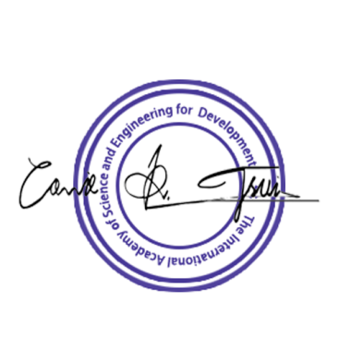
Finally, we suggest you write down a biographical sketch here, for use of making introductions by Session Chair before your presentation gets started.
20-120 Words(1-6.5 lines)

JCMME 2018 Conference Committee
Wellington, New Zealand

