JCMME 2021 Registration Form
2021 4th International Joint Conference on Metallurgical and Materials Engineering (JCMME 2021)
18-20 June 2021|Oslo, Norway |www.jcmme.org
NOTE: Please send the required documents: 1. final paper(doc&pdf), 2. filled registration form, 3. Payment Voucher to jcmme@iased.org (Mail Subject: Paper ID+Registration).
- ATTENDEE INFORMATION

1-inch-Photo here
*Full Name:
*Position√: Prof. □  Assoc. Prof. □  Asst. Prof. □ Dr. □  Mr. □  Ms. □
*Affiliation:
*Nationality:
*Email: *Mobile Phone:
Emergency Contact(Name&Mobile):
Address& Zip Code (for post use):
Catering Service(June 19)√: Lunch □ Dinner □
Special dietary√: Diabetic □ Vegetarian □ Halal food □ Other □ (please specify: )
Special requirements:
- PAPER INFORMATION
*Paper ID: *Paper Pages: *Additional Page:
*Paper Tile:
*Authors:
*Will you attend the conference Yes □ No □
*Presentation Type√: Oral □ Poster □ Remote Video □ Video □
Student ID No.(student only):
IASED Member No.(member only):
* Receipt Issued to:
- REGISTRATION FEE(by US dollar)
Category | Early  (Until Feb. 20) | Regular  (Until April.15) | Late  (After April.15) | On-site  June.18-19 | Online presentation | Your Choice
IASED Member Author | USD 600 | USD 650 | USD 700 | USD 750 | USD 350
Nonmember Author | USD 650 | USD 700 | USD 750 | USD 800 | USD 380
Student Author | USD 550 | USD 600 | USD 650 | USD 700 | USD 320
Presentation Only | USD 450 | USD 500 | USD 550 | USD 600 | USD 250
Listener | USD 380 | USD 450 | USD 500 | USD 550 | USD 200
Social Networking Event | TBD
Academic Visit Optional | TBD

Extra Item | Cost | Your Choice
Extra Page/Per page | USD 70
Extra Paper Upload | USD 370
Extra Banquet Ticket | USD 70
*Notice
*Ordinary length limits is 5-10 pages per paper, If the paper exceeds 6 pages, the additional pages will be charged.
*All papers will be published on-line.
*For "No shows", registration fee is nonrefundable.
*Cancellation policy: A written refund/cancellation request received by 30 December 2020 can be accepted, and a US$100 administrative fee will be charged. After 30 December 2020, the refund/cancellation request will not be accepted.
*Presentation only fee covers: Attend meeting session of June. 19 only to do presentation(not publish paper)+ coffee
breaks, lunch and dinner+ conference kits.
*Full registration fee covers :(Author only) publication fee + meeting sessions on June. 18-20 + 2 coffee breaks, 1 lunch, 1 dinner on June. 19 + conference kits.
- PAYMENT INFORMATION
Online Payment linkage
http://meeting.yizhifubj.com.cn/web/main.action?meetingId=351
* VISA /Master can valid. No handling fees, please calculate the amount and pay.
Please fill your E-mail address used for payment and Confirmation Number you received after paying.
E-mail: | Confirmation Number:
* As the system will intercept the email address for multiple payments, it is recommended to use different email for each payment
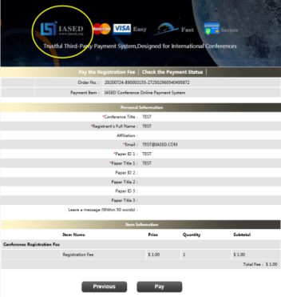
*Please make sure the conference organizer, IASED’s logo is always appear on the page until you click “ Pay”. Then you will be directed to payment page.
- IASED MEMBER APPLICATION
Join IASED now to quality for member registration rates. Please compile and return the Membership Form along with your CV to membership@iased.org. Your application will be processed in 5 working days.
- OTHER
Finally, we suggest you write down a biographical sketch here, for use of making introductions by Session Chair before your presentation gets started.
20-120 Words(1-6.5 lines)

JCMME 2021 Conference Committee
Oslo, Norway

